OSPF neighborship with VSX pair and HSRP pair

**Labels: ArubaOS-CX Switches**

**Requirement:**

Recommendation from best practices guide suggests that there should be an MC-LAG with VSX pair and uplink.

But what if on the other side of VSX pair, aggregation is not possible ?

This short article shows how neighborship of VSX pair with Cisco's HSRP Active and Standby members looks in CLI.

Before we see more, we should keep in mind that for other devices in topology VSX primary/secondary are two different devices from layer 3 perspective and single device from layer 2 perspective.

**Solution:**

***Setup:***

Cisco's Catalyst 3750 and Aruba's 6405 chassis is used to make OSPF neighborships.

Top left is hsrp1,top right is hsrp2

Bottom left is VSX primary, bottom right is VSX secondary.

For easier understanding, only interface vlan3 is used and all OSPF neighbors are in same broadcast domain under backbone area(area 0).

And yes there is one port blocked by STP in this looped topology, which is port on hsrp2 facing vsx secondary.

[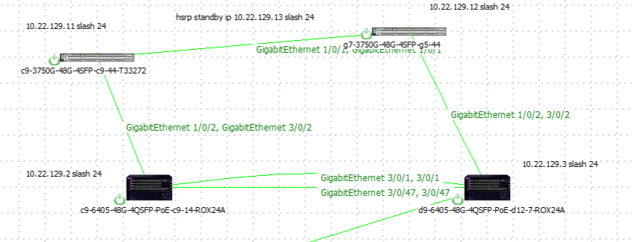](https://akb.arubanetworks.com/media/ckuploads/1110/2021/10/31/setup-vsx-and-hsrp.PNG)

**Configuration:**

***Background:***

Output in yellow is from HSRP pair, in blue is VSX pair.

hsrp1 10.22.129.11

hsrp2 10.22.129.12

HSRP virtual ip 10.22.129.13

VSX primary 10.22.129.2

VSX secondary 10.22.129.3

This image shows hsrp members and ospf neighborships without active-gateway configuration in VSX pair.

Designated router is hsrp2 and sees every other neighbor as either BDR or DROther

[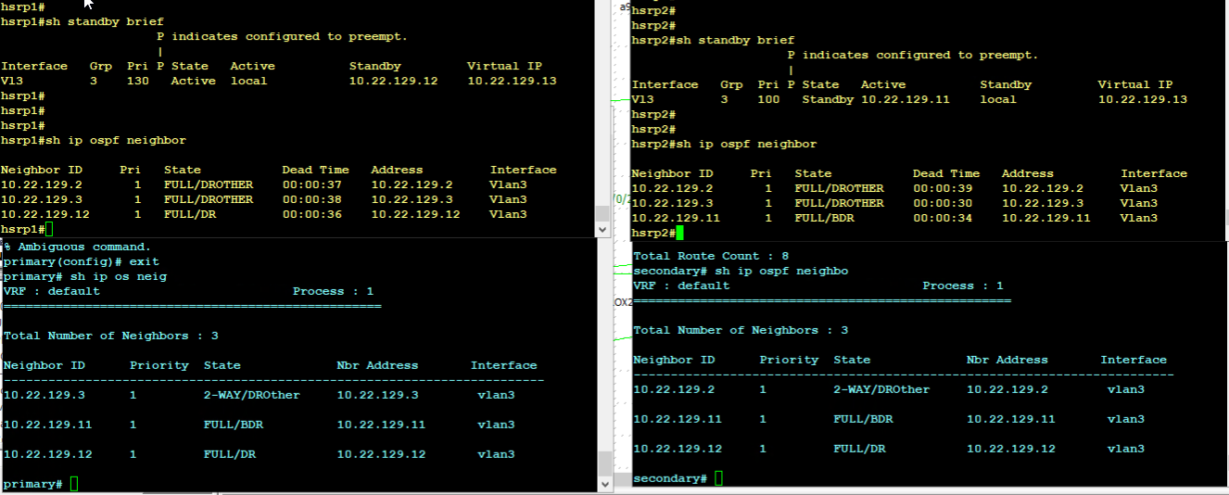](https://akb.arubanetworks.com/media/ckuploads/1110/2021/10/31/without-active-gateway-vlan-3_flERtRa.PNG)

**Verification:**

With Active-gateway(10.22.129.1) setting in VSX.

We can see there is no difference in OSPF neighborship IPs, it remains same irrespective of active-gateway, just like HSRP virtual IP.

[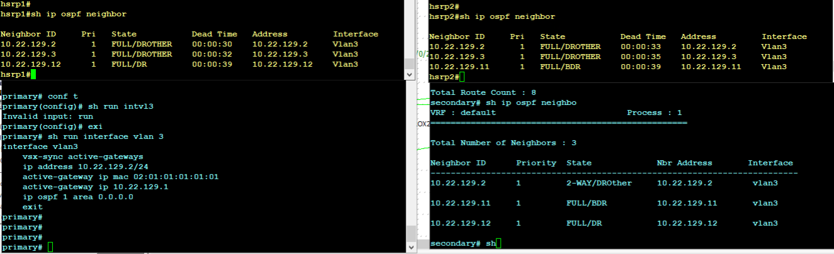](https://akb.arubanetworks.com/media/ckuploads/1110/2021/10/31/with-active-gateway-vlan-3.PNG)

VSX primary advertising loopback 40 IP.

[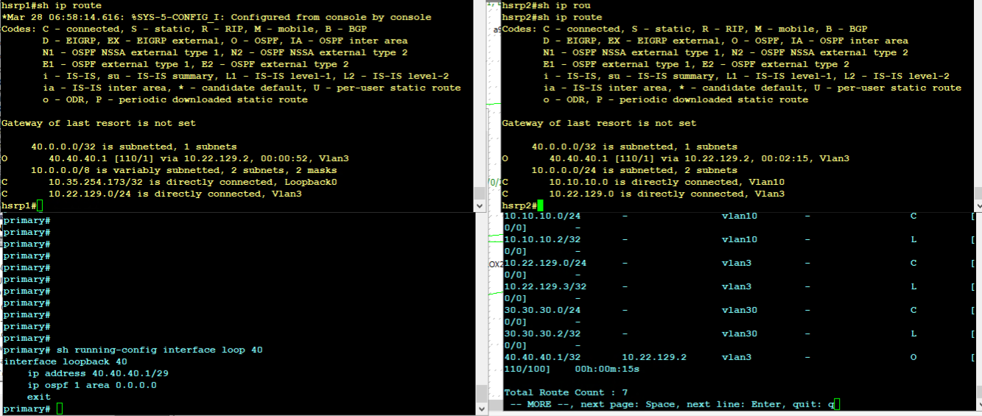](https://akb.arubanetworks.com/media/ckuploads/1110/2021/10/31/with-active-gateway-vlan-3-primary-advertising-loopback40-ip.PNG)

hsrp1 advertising loopback50 IP.

[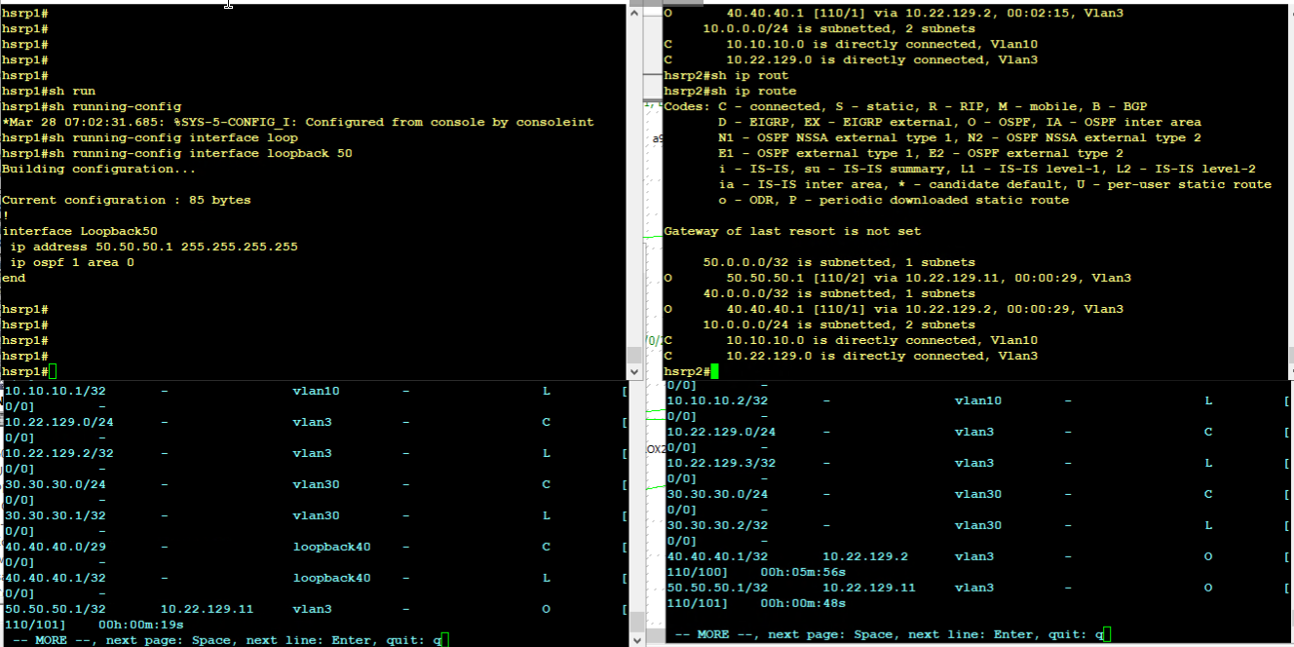](https://akb.arubanetworks.com/media/ckuploads/1110/2021/10/31/with-active-gateway-vlan-3-hsrp1-advertising-loopback50-ip.PNG)

Using active gateway as next-hop on hsrp1 for a loopback off VSX secondary

[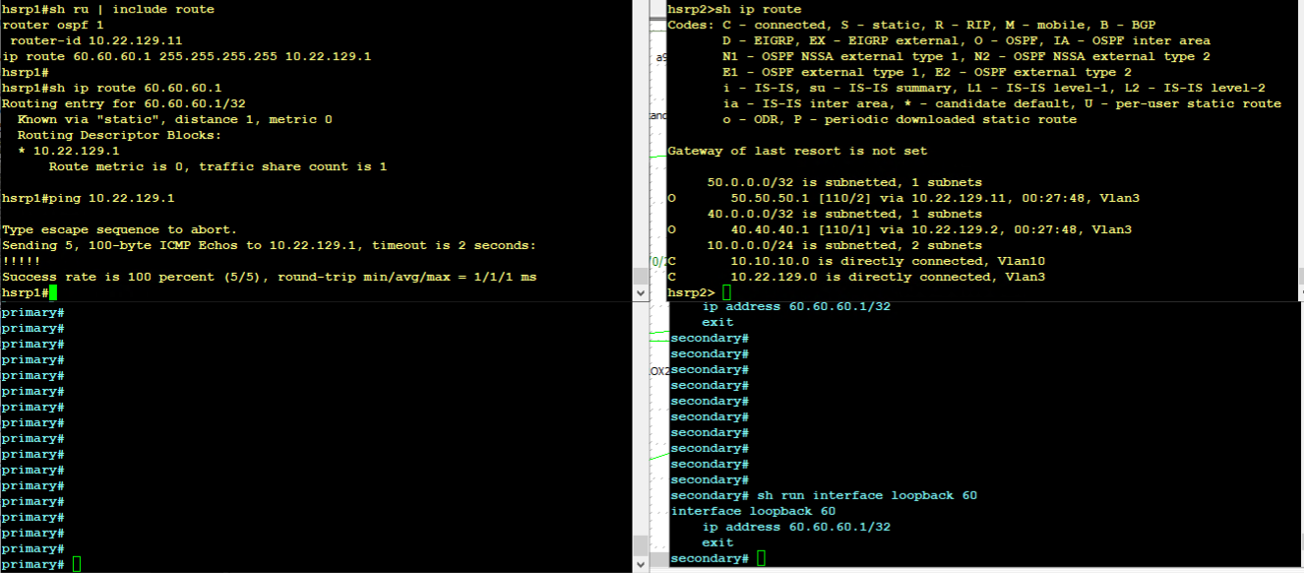](https://akb.arubanetworks.com/media/ckuploads/1110/2021/10/31/on-hsrp-router-static-route-pointing-to-active-gaetway.PNG)

OSPF priority(priority to become designated router in same LAN) is changed on 6400 primary to 90. Default is 1.

Please note, mere changing of priority on primary VSX does not change the state of neighborship. hsrp2 only sees primary vsx as DR only after ospf process is reset on primary VSX.

As shown below, although hsrp2 learns the new priority of 90 from vsx primary, but state remains same until ospf process is reset.

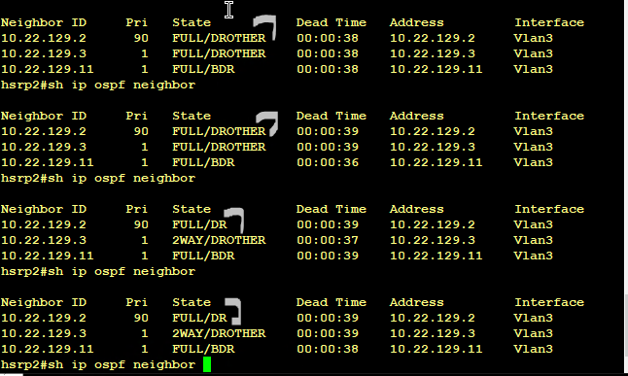

Tags: ArubaOS-CX Switches, arubaos-cx 10.07.xxxx, #arubaos-cx, #6400, #ospf, hsrp, #cisco, #vsx, #active gateway